**Day 4 - 22nd May 2025**

**Task 1:   
  
What do you know about cloud?**

"The cloud" refers to servers that are accessed over the Internet, and the software and databases that run on those servers. Cloud servers are located in [data centers](https://www.cloudflare.com/learning/cdn/glossary/data-center/) all over the world. By using cloud computing, users and companies do not have to manage physical servers themselves or run software applications on their own machines.

**Types of cloud:**

* Private cloud
* Public cloud
* Hybrid cloud
* Multi-cloud

**Task 2:**

**Jdk Installation**

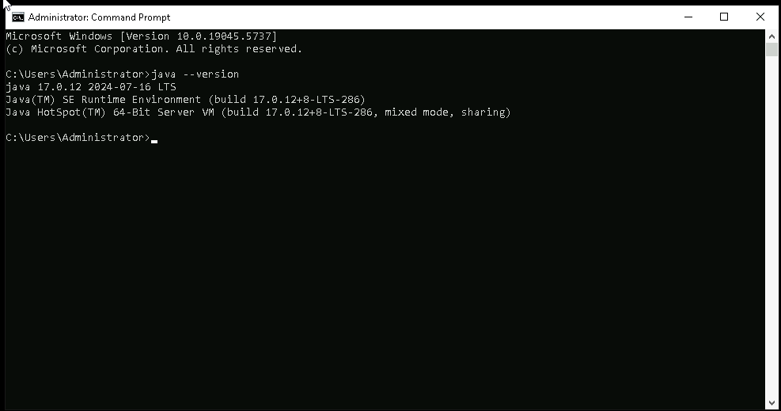

**Task 3:**

**Jenkins installation**

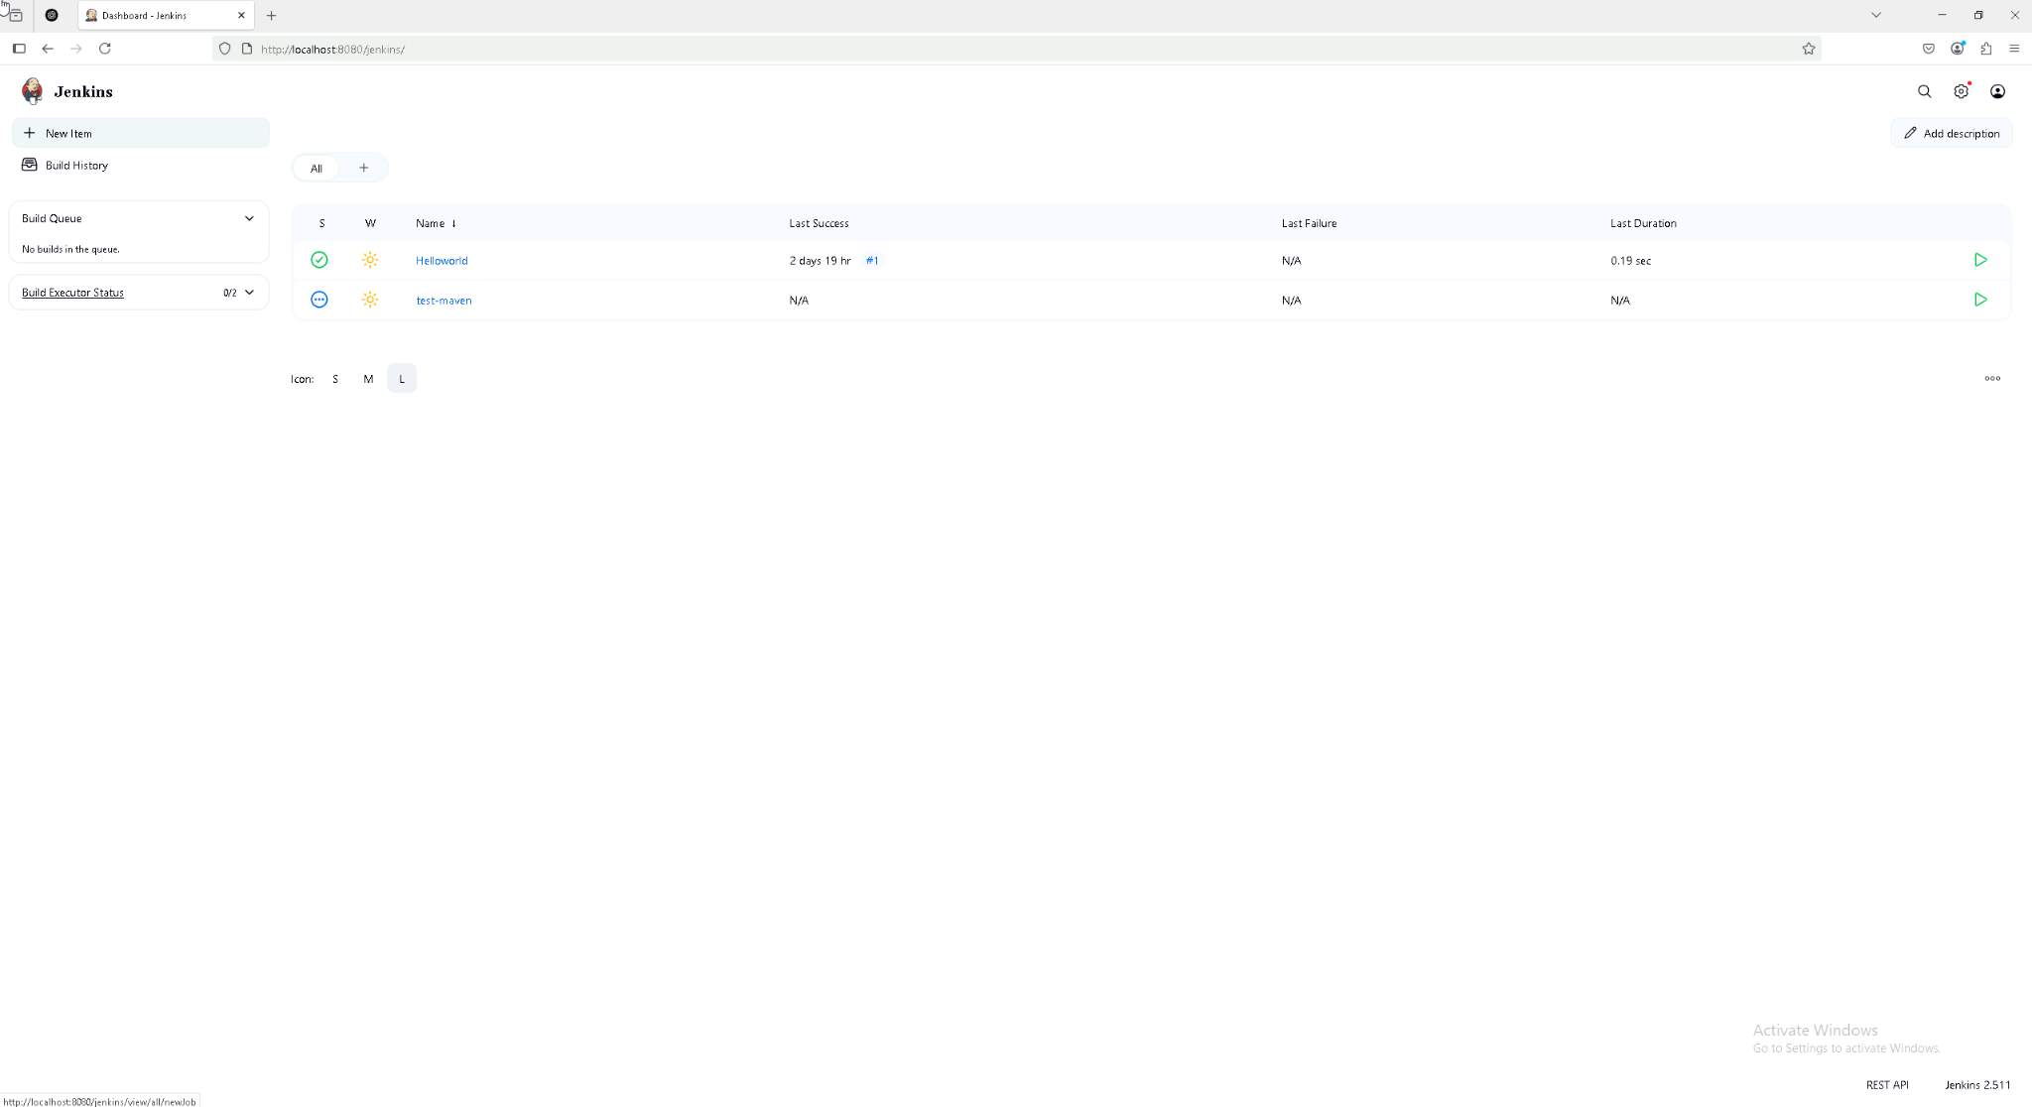

**Task 4**

**First Freestyle job build**

